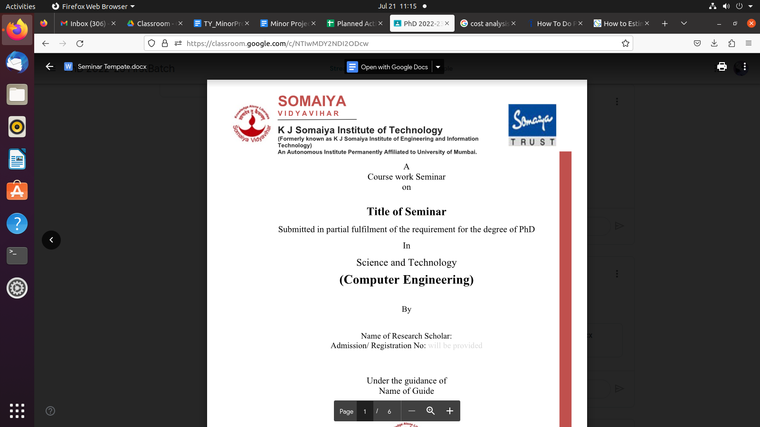

**KJSIT’s Student Achievement Portal and Optical Character Recognition Tool**

**TY Minor Project Report**

**Submitted in partial fulfilment of the requirements of the Degree of Bachelor of Technology in Computer Engineering**

by

**Kapil Bhatia**

**Palak Desai**

**Devanshi Joshi**

**Dakshita Kolte**

**Supervisor**

**Dr. Jyoti Wadmare**



Department of Computer Engineering

K.J. Somaiya Institute of Technology, Mumbai

**An Autonomous Institute affiliated to University of Mumbai**

**Ayurvihar, Sion, Mumbai – 400022**

**2023-24**



**CERTIFICATE**

*This is to certify that the project entitled* ***“KJSIT’s Student Achievement Portal and Optical Recognition Tool”*** *is bonafide work of* ***Kapil Bhatia, Palak Desai, Devanshi Joshi, Dakshita Kolte*** *submitted to the University of Mumbai in partial fulfilment of the requirement in Project, for the award of the degree of “****Bachelors of Technology****” in “****Computer Engineering****”.*

**Dr. Jyoti Wadmare**

**Project Guide**

**Assistant Professor**

**Department of Computer Engineering**

**Dr. Vivek Sunnapwar**

**Principal**

**KJSIT**

**Dr. Sarita Ambadekar**

**Head of Department**

**Dept. of Computer Engineering**

**PROJECT APPROVAL FOR T.Y.**

The project report entitled KJSIT’s Student Achievement Portal and Optical Character Recognition Tool by

Kapil Bhatia (5)

Palak Desai (10)

Devanshi Joshi (24)

Dakshita Kolte (31)

is an approved Third Year Project in **Computer Engineering**.

Examiners

1.

2.

Date: 21st November, 2023

Place: Sion, Mumbai – 400022

**DECLARATION**

We declare that this written submission represents our ideas in our own words and where other’s ideas or words have been included, we have adequately cited and referenced the sources. We also declare that we have adhered to all the principles of academic honesty and integrity and have not misrepresented or fabricated or falsified any idea/data/fact/ source in our submission. We understand that any violation of the above will be cause for disciplinary action by the Institute and can also evoke penal action from the sources which have thus not been properly cited of from whom proper permission has not been taken when needed.

Kapil Sunil Bhatia

Palak Piyush Desai

Devanshi Ketan Joshi

Dakshita Sanjay Kolte

Date:

**ACKNOWLEDGEMENT**

Before presenting our Minor Project work entitled “**KJSIT’s Student Achievement Portal and Optical Character Recognition Tool**”, we would like to convey our sincere thanks to the people who guided us throughout the Program for this project work.

First, we would like to express our sincere thanks to our beloved Principal **Dr. Vivek Sunnapwar** and Vice principal **Dr. Sunita Patil** for providing various facilities to carry out this report.

We would like to express our immense gratitude towards our **Dr. Jyoti Wadmare** for the constant encouragement, support, guidance, and mentoring at the ongoing stages of the project and report.

We would like to express our sincere thanks to our **H.O.D. Dr. Sarita Ambadekar**, for the encouragement, co-operation, and suggestions progressing stages of the report.

Finally, we would like to thank all the teaching and non-teaching staff of the college, and our friends, for their moral support rendered during the Program of the reported work, and for their direct and indirect involvement in the completion of our report work, which made our endeavour fruitful.

Kapil Bhatia

Palak Desai

Devanshi Joshi

Dakshita Kolte

Place: Sion, Mumbai - 400022

Date:

**ABSTRACT**

In the evolving landscape of educational institutions, efficient management of student achievements and records is paramount. KJSIT's Student Achievement Portal emerges as a groundbreaking solution, introducing a seamless process for collecting and managing diverse certificates. This comprehensive system features two distinct interfaces: one tailored for students and another for administrators. Students experience a user-friendly platform, simplifying the uploading of certificates and enhancing their engagement. Meanwhile, administrators benefit from an array of tools, enabling streamlined oversight of student activities and certificates.

Central to this innovation is the integration of an Optical Character Recognition (OCR) tool, a technology that automates the extraction of vital information from certificates. This OCR tool reads, recognizes, and transforms text from certificates into a digital format, significantly reducing the need for manual data entry. The extracted data is stored systematically in Excel files, creating a structured repository for easy accessibility and management. Notably, this project also aims to provide an accessible and cost-effective OCR solution, eliminating financial barriers associated with similar commercial tools.

*KJSIT's Student Achievement Portal* stands at the forefront of certificate management, offering unparalleled efficiency, accuracy, and accessibility. By leveraging OCR technology, this project not only simplifies administrative tasks but also enhances the overall educational experience for both students and administrators.

**Content**

|  |  |  |
| --- | --- | --- |
| **Sr. No.** | **Content** | **Page No.** |
| 1 | Certificate | ii |
| 2 | Declaration | iv |
| 3 | Acknowledgement | v |
| 4 | Abstract | vi |
| 5 | Introduction   * 1. About KJSIT’s Student Achievement Portal   2. About Optical Character Recognition Tool | 1  1  2 |
| 6 | Literature Review | 3 |
| 7 | Requirement specification | 5 |
| 8 | Requirement specification  3.1 Introduction  3.2 Software Requirements | 5  5  5 |
| 9 | Project analysis and design  4.1 Estimate Summary  4.2 Effort Estimate  4.3 Network Cost Estimate  4.4 Admin cost | 8  8  8  9  9 |
| 10 | Methodology  5.1 Functionalities at Student Side  5.2 Functionalities at Admin Side  5.3 Working of Optical Recognition Tool | 10  10  11  12 |
| 11 | Implementation | 14 |
| 12 | Results and Analysis | 29 |
| 13 | Conclusion | 30 |
| 14 | References | 32 |

**List of Figures**

|  |  |  |
| --- | --- | --- |
| **Figure No.** | **Title** | **Page No.** |
| 5.1 | Student Functionalities | 10 |
| 5.2 | Admin Functionalities | 11 |
| 5.3 | Working of OCR Tool | 13 |
| 6.1 | Home Page | 14 |
| 6.2 | Login Page for Student/Admin | 14 |
| 6.3 | Student Signup Page | 15 |
| 6.4 | Student Login Page | 15 |
| 6.5 | Student Dashboard Page | 16 |
| 6.6 | Student Profile Page | 16 |
| 6.7 | Student Change Password Page | 17 |
| 6.8 | Student Certificate Upload | 17 |
| 6.9 | Student Certificate Upload History Page | 18 |
| 6.10 | My Account | 18 |
| 6.11 | Student Sidebar | 19 |
| 6.12 | Admin Login Page | 19 |
| 6.13 | Admin Sidebar | 20 |
| 6.14 | View Student Profile Page | 21 |
| 6.15 | View Uploaded Certificate Page | 21 |
| 6.16 | Add Faculty Page | 22 |
| 6.17 | View Faculty Record Page | 22 |
| 6.18 | Add Program Page | 23 |
| 6.19 | View Program Details Page | 23 |
| 6.20 | Add Admin Page | 24 |
| 6.21 | View Admin Details Page | 24 |
| 6.22 | About Us Page | 25 |
| 6.23 | About Us Page | 25 |
| 6.24 | About Us Page | 26 |
| 6.25 | About Us Page | 26 |
| 6.26 | Optical Character Resolution Tool Page 1 | 27 |
| 6.27 | Optical Character Resolution Tool Page 2 | 27 |
| 6.28 | Optical Character Resolution Tool Excel Downloaded | 28 |

**List of Tables**

|  |  |  |
| --- | --- | --- |
| **Table No.** | **Title** | **Page No.** |
| 4.1 | Estimate Summary | 8 |
| 4.2 | Effort Estimate | 8 |
| 4.3 | Network Cost Estimate | 8 |
| 4.4 | Admin cost | 9 |

**CHAPTER 1**

**INTRODUCTION**

**1.1 About KJSIT’s Student Achievement Portal**

KJSIT's Student Achievement Portal is a comprehensive software solution developed with the primary goal of collecting data from students in the form of certificates to establish a systematic tracking system for their various accomplishments. The certificates gathered from students encompass a wide range of categories, including:

1) Certificates of Internships

2) Curricular Certificates

3) Certificates for Co-curricular Activities

4) Certificates of Extra-curricular Involvement

5) Certificates for Sports Achievements

6) Certificates of Activities Organized

7) Certificates for Awards Received

8) Certificates for Programs Completed

9) Certificates of Participation in Various Events

10) Certificates of Selection in Competitions

11) Certificates for Seminars or Webinars Attended

12) Letters of Appreciation

The portal is designed with two distinct sides: the Student side and the Admin side. On the Student side, users have the capability to upload their certificates, while on the Admin side, administrators can access and review the certificates uploaded by students. Additionally, the portal is equipped with an Optical Character Recognition (OCR) tool that facilitates the extraction of text from these certificates. The extracted information is then stored in Excel files, ensuring efficient and effective tracking and management of students' diverse achievements and records.

**1.2 About Optical Character Recognition Tool**

An Optical Character Recognition (OCR) tool is a software or hardware technology designed to recognize and convert printed or handwritten text from documents, images, or other visual sources into machine-readable text. In essence, OCR enables the transformation of scanned or photographed text into digital, editable content.

OCR in computer vision extracts text from images or scanned documents by locating text regions, segmenting text, recognizing characters, and outputting the recognized text. It's used for tasks like digitizing documents and enabling text-based searches in images.

On the Admin side of the portal, administrators have the capability to access and review the certificates that students have uploaded. The portal incorporates an Optical Character Recognition (OCR) tool, which is a technology designed to extract text from the certificates. This OCR tool reads the text on the certificates, such as names, dates, and details of achievements, and then converts this information into a digital format. The extracted text is subsequently organized and stored in Excel files. Excel files are a common format for storing data in a structured manner. These files act as a repository for the extracted information, making it easily accessible for administrators. This approach not only ensures efficiency but also promotes effective tracking and management of the diverse achievements and records of the students.

**CHAPTER 2**

**REVIEW OF LITERATURE**

In the traditional data collection approach, students were required to submit their records using Google Forms. To do so, they had to complete the forms by providing their personal details and uploading the necessary certificates. Multiple Google Forms were created to cater to various types of certificate records, and students were often directed to separate drive links for uploading their certificates. Consequently, students found themselves completing multiple forms and uploading certificates multiple times in order to submit their data to the relevant authorities.

Faculties were responsible for manually maintaining a Google Sheet or Excel document in which all student data was recorded. This meant that either faculty members entered student information themselves or students were instructed to input their data. Unfortunately, this method proved to be a tedious and time-consuming process for both students and faculty members.

To streamline and simplify the data collection process, KJSIT Student Achievement Portal is developed and it is integrated with Optical Character Recognition Tool. With this solution, students are only required to register and log in once, and they can conveniently upload their certificates through the student dashboard.

The admin side of the portal has an Optical Character Recognition Tool. This tool plays a crucial role by automatically extracting data from the certificates uploaded by students. The extracted data is then efficiently stored in Excel files. This innovative system eliminates the need for students to repeatedly fill out forms and upload certificates, making the process far more user-friendly and efficient. Simultaneously, it relieves administrative burdens by automating the data extraction and storage processes, resulting in a more streamlined and effective approach to managing student achievements and records.

Many OCR tools which are available online are paid. Some of the paid software’s to extract data from certificates and store them in Excel files are:

1. ABBYY FineReader

2. Readiris

3. Adobe Acrobat Pro DC

4. Kofax Capture

5. Captricity

With this goal in mind, an initiative has been undertaken to develop a free OCR tool designed to extract data from certificates and subsequently store it in Excel format, all without any cost to the users.

This effort seeks to address the need for an accessible and cost-effective solution for data extraction from certificates. The planned tool aims to automate the process of recognizing and capturing text from certificate images, making it user-friendly and eliminating the financial barriers associated with traditional paid OCR software.

**CHAPTER 3**

**REQUIREMENT SPECIFICATION**

**3.1 Introduction**

KJSIT's Student Achievement Portal and Optical Character Recognition (OCR) tool, is a software developed to collect various student achievement records. This comprehensive system comprises two distinct sides: the student side and the admin side.

On the Student side, users have the capability to upload their certificates, while on the Admin side, administrators can access and review the certificates that students have submitted. In addition to this, the portal is equipped with an OCR tool that facilitates the extraction of text from these certificates.

The extracted information is then efficiently stored in Excel files, ensuring an organized and effective approach to tracking and managing the diverse achievements and records of the students.

**3.2 Software Requirements**

**3.2.1 KJSIT’s Student Achievement Portal**

***Frontend***

1. HTML (Hypertext Markup Language):

HTML is used for creating the structure and content of web pages, defining elements and their layout.

1. CSS (Cascading Style Sheets):

CSS is employed for styling web pages, specifying how the HTML elements should be displayed, and controlling their visual presentation.

1. Bootstrap:

Bootstrap is a front-end framework that simplifies the process of building responsive and visually appealing web interfaces by providing pre-designed components and responsive layouts.

1. JavaScript:

JavaScript is a versatile scripting language used for adding interactivity to web pages, enabling dynamic behavior and user interactions.

***Backend***

1. jQuery:

jQuery is a JavaScript library that simplifies complex tasks like DOM manipulation, event handling, and AJAX requests, making web development more efficient.

1. PHP (Hypertext Preprocessor):

PHP is a server-side scripting language used for creating dynamic web pages and handling server-side logic, such as form processing and database interactions.

***Database***

1. MySQL:

MySQL is a popular open-source relational database management system used for storing and managing data, making it an integral component for data storage and retrieval in web applications like the Student Achievement Portal.

**3.2.2 Optical Character Recognition Tool**

***Language Used***

1. Python:

Python is a high-level, versatile programming language known for its simplicity, readability, and extensive library support, making it widely used for various applications, from web development to data analysis.

***Python Libraries used in Computer Vision***

1. OpenCV (Open-Source Computer Vision Library):

OpenCV is a widely-used computer vision library that provides a wide range of tools and functions for image and video analysis, including image processing and object detection.

1. NumPy:

NumPy is a fundamental library for numerical operations in Python, used for array handling and mathematical computations, essential for image processing.

1. Pytesseract:

 Pytesseract is a Python wrapper for the Tesseract OCR engine, enabling text extraction from images and other visual data.

***Python Libraries used in Natural Language Processing:***

1. SpaCy:

SpaCy is a natural language processing library that offers tools for text processing, part-of-speech tagging, entity recognition, and more, making it useful for language understanding tasks.

1. Pandas:

Pandas is a data manipulation library that provides data structures and functions for data analysis and manipulation, including data loading, cleaning, and transformation.

1. Regular Expression:

Regular expressions (regex) in Python enable pattern matching and text manipulation, facilitating text processing tasks such as searching and extraction.

1. String:

Python's built-in string module offers various functions and methods for working with strings, which is integral for text manipulation and analysis in natural language processing.

**CHAPTER 4**

**PROJECT ANALYSIS AND DESIGN**

**4.1 Estimate Summary**

|  |  |
| --- | --- |
| **Type** | **Estimate Cost** |
| Effort | Rs. 30,000.00 |
| Software | Rs. 6,000.00 |
| Network | Rs. 5,000.00 |
| Ongoing | Rs. 4,000.00 |
| Admin cost not in overhead | Rs.5,000.00 |
| **Subtotal** | **Rs. 50,000.00** |

**4.2 Effort Estimate**

|  |  |  |  |  |  |  |
| --- | --- | --- | --- | --- | --- | --- |
| **Task ID** | **Task Name** | **Resource** | **Resource Quantity** | **Rate per hour** | **Efforts Required** | **Estimation Efforts** |
| 1 | A | IT | 2 | Rs. 500.00 | 20 | Rs. 10,000.00 |
| 2 | B | IT | 1 | Rs. 500.00 | 10 | Rs. 5,000.00 |
| 3 | C | IT | 4 | Rs. 500.00 | 20 | Rs. 10,000.00 |
| 4 | D | IT | 3 | Rs. 500.00 | 10 | Rs. 5000.00 |
| **Total** | | | | | | **Rs. 30,000** |

**4.3 Network Cost Estimate**

|  |  |  |  |
| --- | --- | --- | --- |
| **Server Network needs** | **Price per Unit** | **Quantity** | **Total** |
| For Development | Rs. 200.00 | 7 | Rs. 1,400.00 |
| For Test | Rs. 100.00 | 5 | Rs. 500.00 |
| For Training | Rs. 100.00 | 3 | Rs. 300.00 |
| For Production | Rs. 100.00 | 3 | Rs. 300.00 |
| **Total** | | | **Rs. 2,500.00** |

|  |  |  |  |
| --- | --- | --- | --- |
| **Desktop Network needs** | **Price per Unit** | **Quantity** | **Total** |
| For Development | Rs. 200.00 | 7 | Rs. 1,400.00 |
| For Test | Rs. 100.00 | 5 | Rs. 500.00 |
| For Training | Rs. 100.00 | 3 | Rs. 300.00 |
| For Production | Rs. 100.00 | 3 | Rs. 300.00 |
| **Total** | | | **Rs. 2,500.00** |

**4.4 Admin cost**

|  |  |
| --- | --- |
| **Type** | **Cost** |
| Travel | Rs. 2,000.00 |
| Facilities | Rs. 3,000.00 |
| **Total** | **Rs. 5,000.00** |

**CHAPTER 5**

**METHODOLOGY**

KJSIT's Student Achievement Portal and Optical Character Recognition (OCR) tool, is a software developed to collect various student achievement records. This comprehensive system comprises two distinct sides: the student side and the admin side.

**5.1 Functionalities at Student Side:**

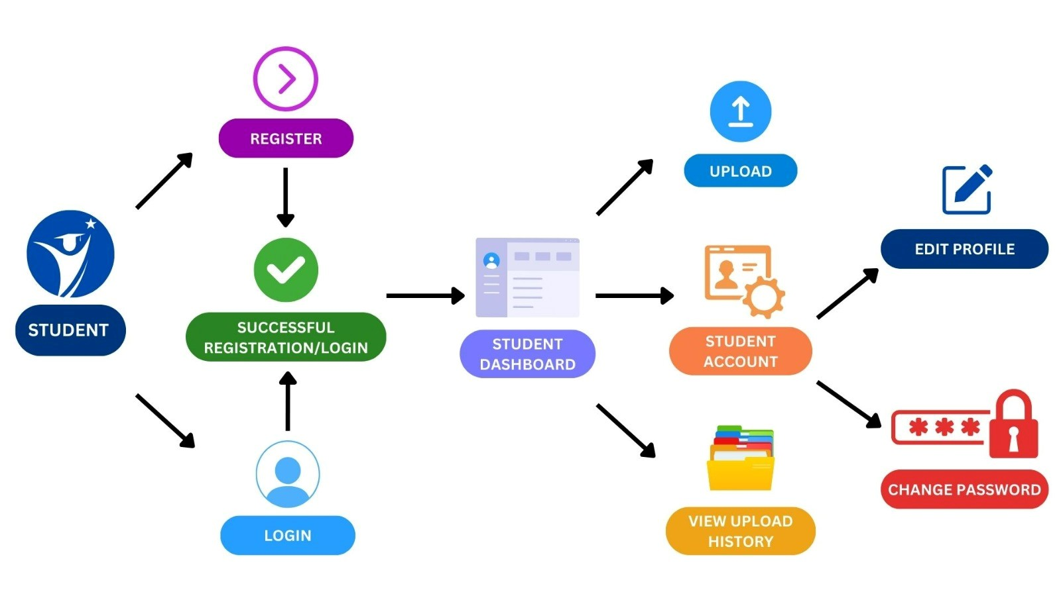

*Fig 5.1. Student Functionalities*

1. User Registration/Login: The student starts by logging in or registering on the website.
2. Student Dashboard: Upon successful login, the student gains access to the student dashboard.
3. Dashboard Options: Within the student dashboard, the user can choose from various options, including:
4. Upload Certificates: The student can select the certificate type from a dropdown menu and then proceed to upload the necessary certificate.
5. Student Account: This section offers two choices:
6. Edit Profile: Here, the user can make changes and updates to their profile information.
7. Change Password: This option allows the user to modify their account password for added security.

**5.2 Functionalities at Admin Side:**

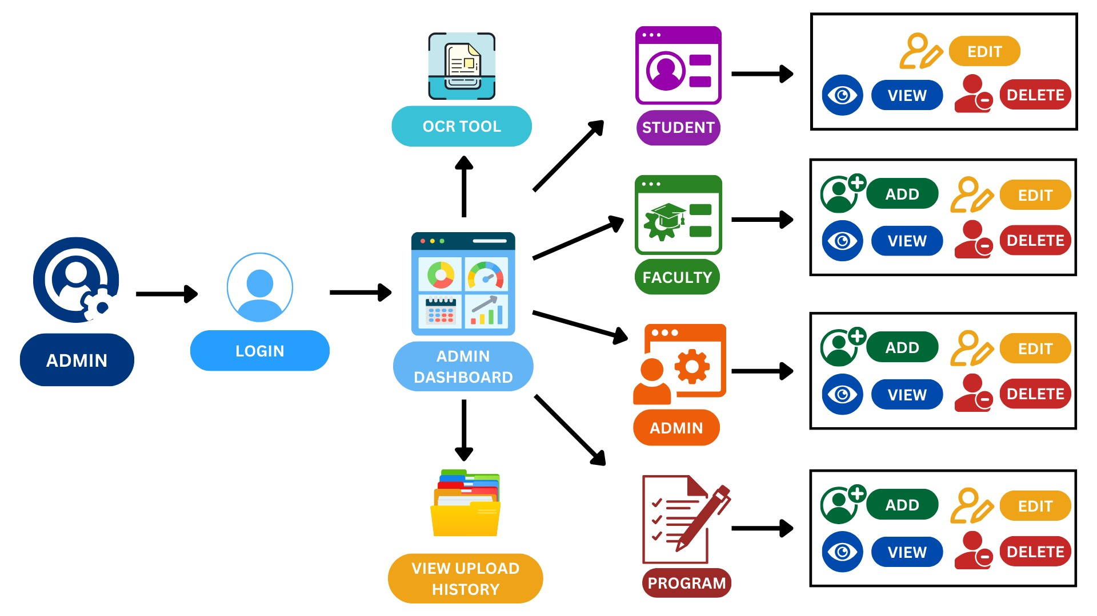

*Fig 5.2 Admin Functionalities*

1. Admin Login: The admin starts by logging into their account.
2. Admin Dashboard: After a successful login, the admin gains access to the dashboard.
3. Certificate Counts: On the dashboard, the total count of certificates uploaded for each type is displayed.
4. Certificates Tab: Within the "Certificates" section, the admin can view user details along with the uploaded certificates.
5. Student Tab: Under the "Student" section, the admin can:
6. View Students: Keep track of registered students, their details, and certificates. They can also edit or delete student information.
7. Faculty Tab: In the "Faculty" section, the admin can:
8. Add Faculty: Add new faculty members to the system.
9. View Faculty: View, edit, or delete existing faculty profiles.
10. Program Tab: Within the "Program" section, the admin can:
11. Add Program: Create and add new Programs to the system.
12. View Program: View, edit, or delete information about the Programs that have been added.
13. Admin Tab: Under the "Admin" section, the admin can:
14. Add Admin: Add new admin users to the system.
15. View Admin: View, edit, or delete existing admin profiles.
16. OCR Tool Tab: The "OCR Tool" section provides a link to an Optical Character Recognition tool. Admins can use this tool to upload certificates, extract data from them, and save the data in Excel files.

**5.3 Working of Optical Recognition Tool**

Step 1: Setup

* 1. Install Python
  2. Install Dependencies

Step 2: Data Preparation

1. Gather Images
2. Utilize Pytesseract for Text Extraction
3. Perform Necessary Text Cleaning

Step 3: Labelling NER Data

1. Manual Labelling using BIO Tagging
2. B - Beginning
3. I - Inside
4. O - Outside

Step 4: Data Preprocessing

1. Prepare Training Data for Spacy
2. Convert Data into Spacy Format

Step 5: NER Model Training

1. Configure NER Model
2. Train the Model

Step 6: NER Predictions and Data Pipeline

1. Load Model
2. Render and Serve with Displacy
3. Draw Bounding Boxes on Images
4. Parse Entities from Text

Final Step: Certificate Scanner Web App Creation

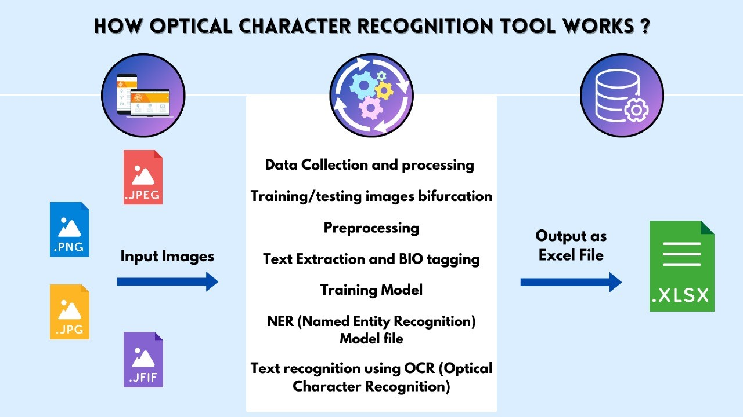

*Fig 5.3. Working of OCR Tool*

**CHAPTER 6**

**IMPLEMENTATION**

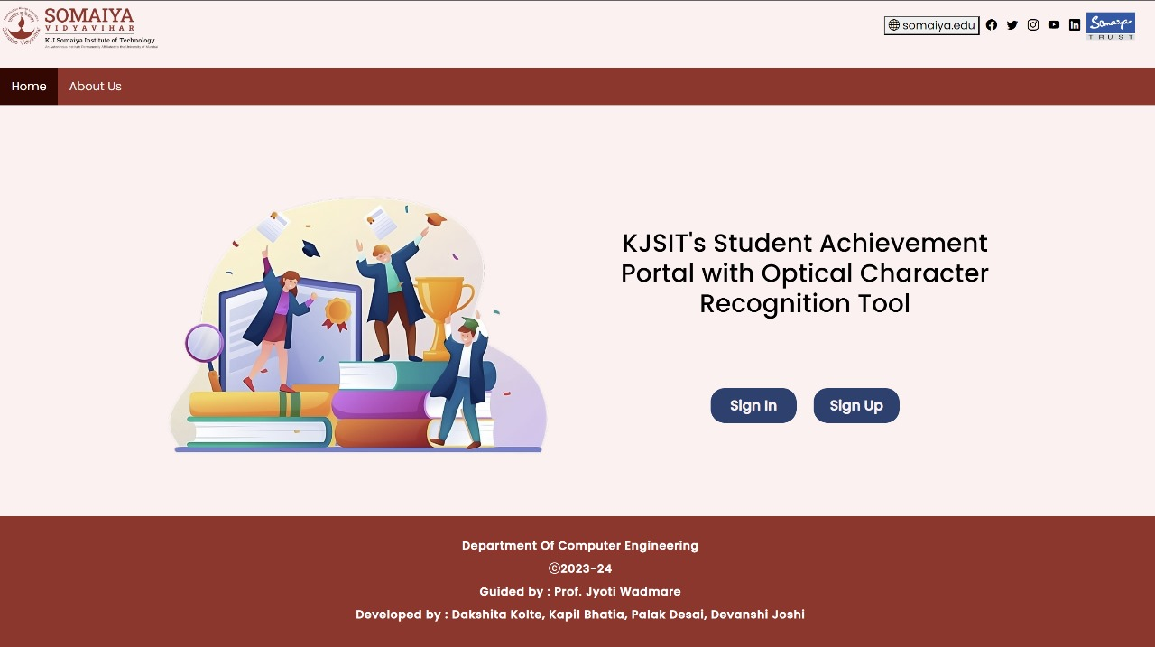

*Fig 6.1. Home Page*

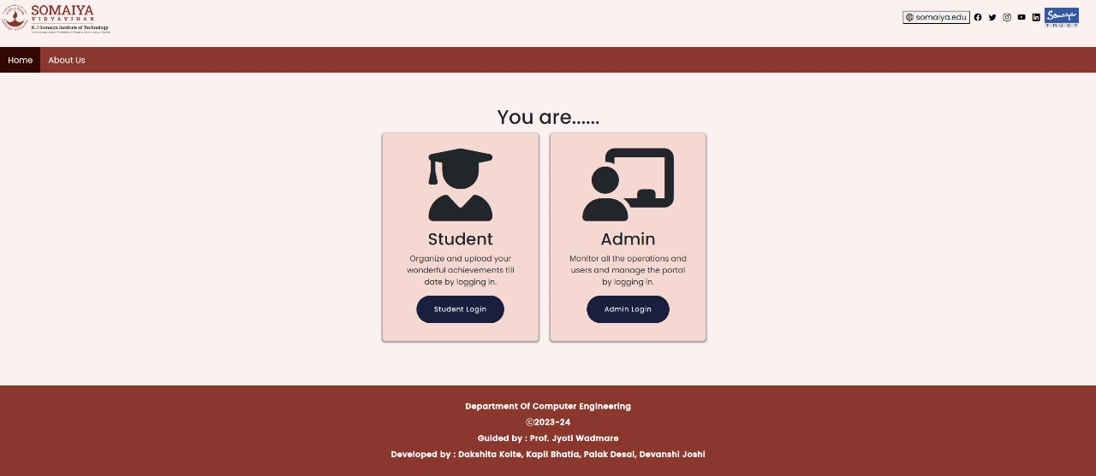

*Fig 6.2. Login Page for Student/Admin*

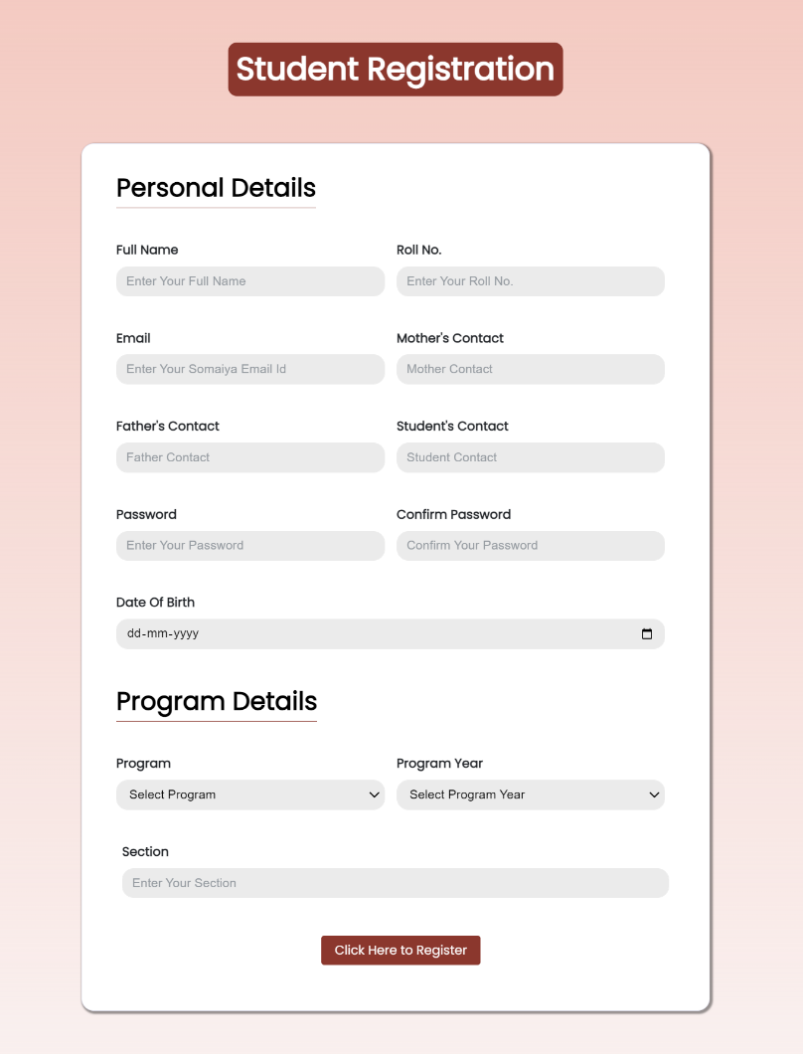

*Fig 6.3. Student Signup Page*

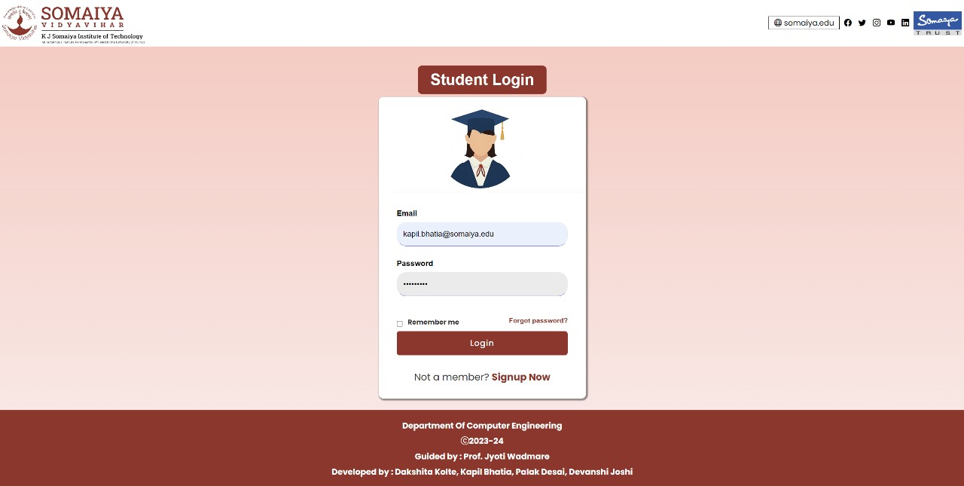

*Fig 6.4. Student Login Page*

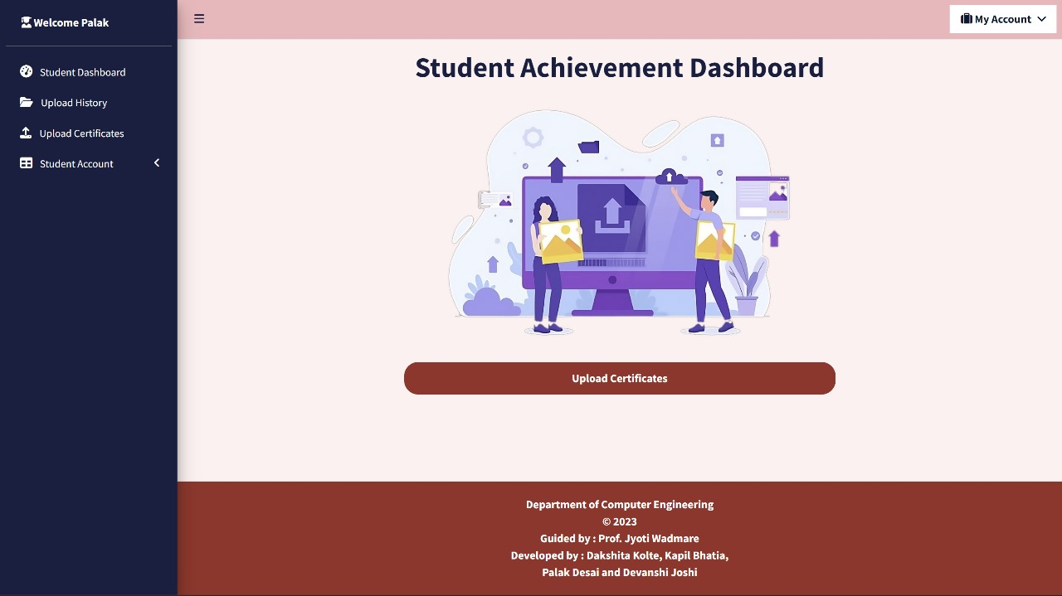

*Fig 6.5. Student Dashboard Page*

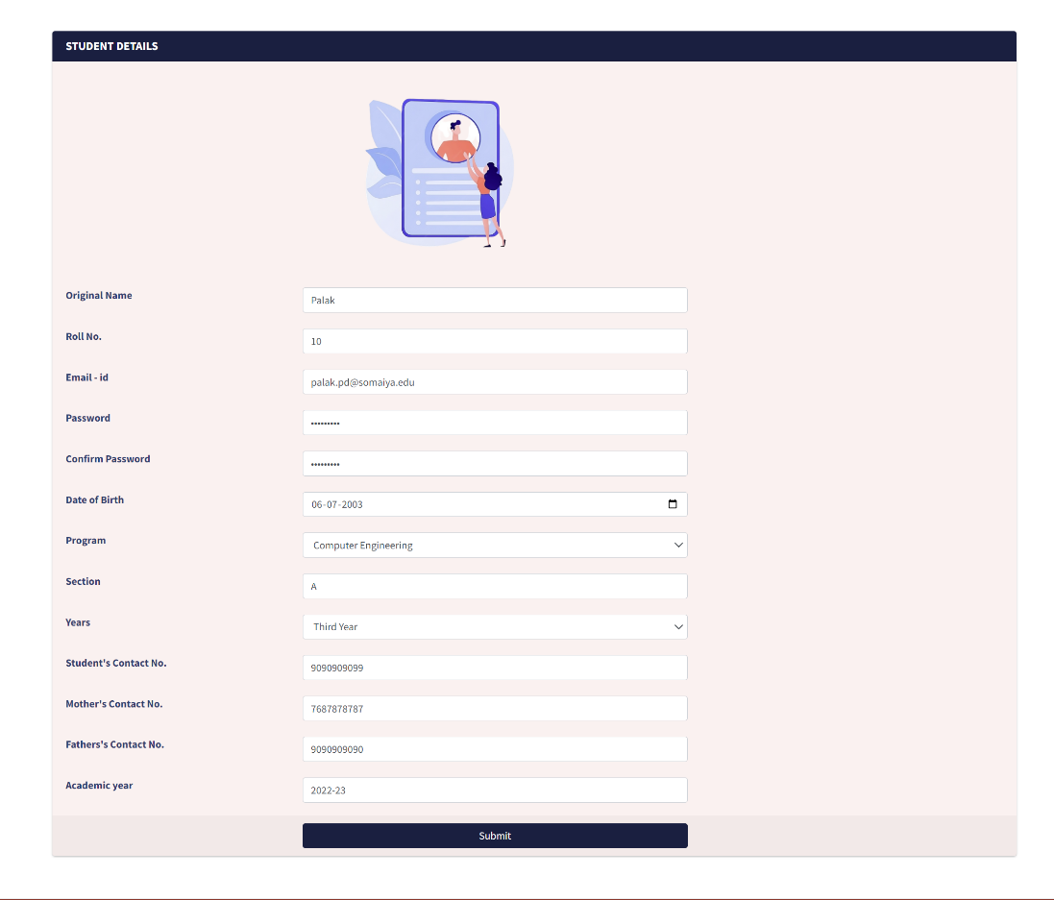

*Fig 6.6. Student Profile Page*

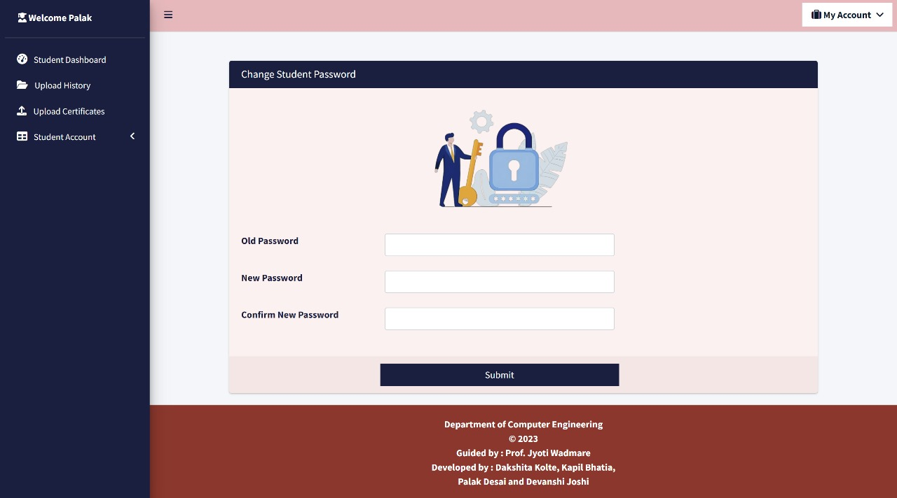

*Fig 6.7. Student Change Password Page*

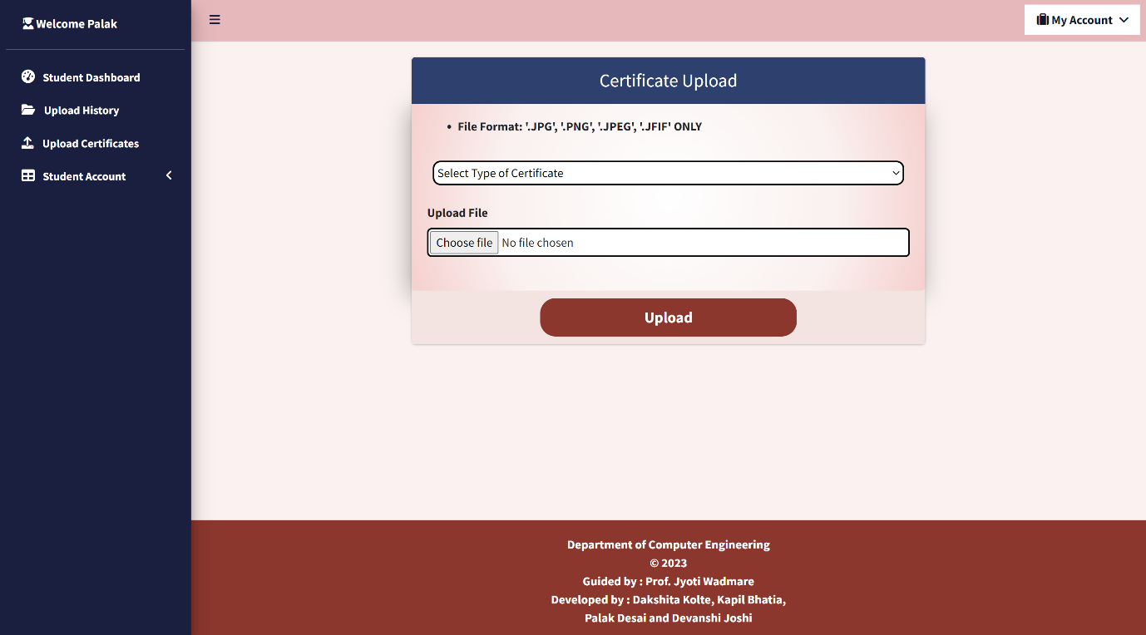 *Fig 6.8. Student Certificate Upload Page*

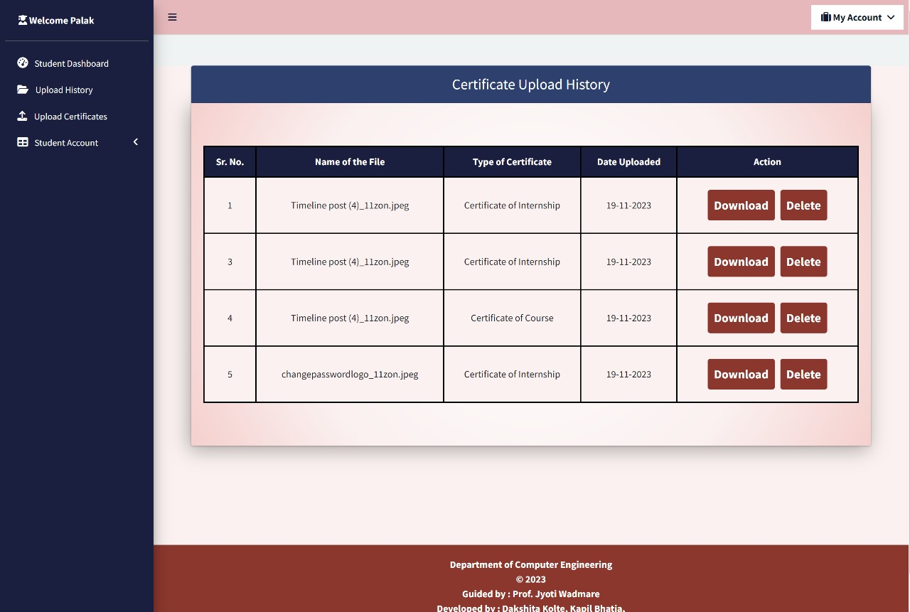

*Fig 6.9. Student Certificate Upload History Page*

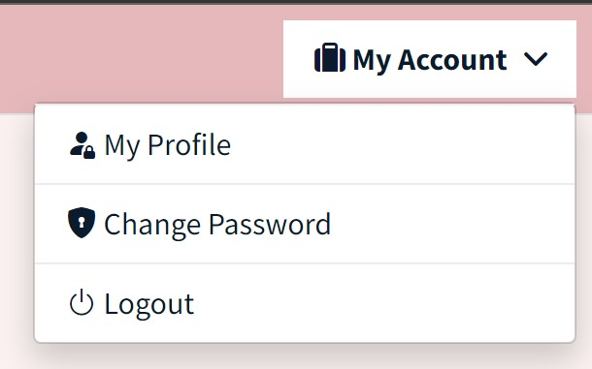

*Fig 6.10. My Account*

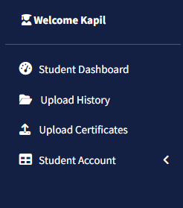

*Fig 6.11. Student Sidebar*

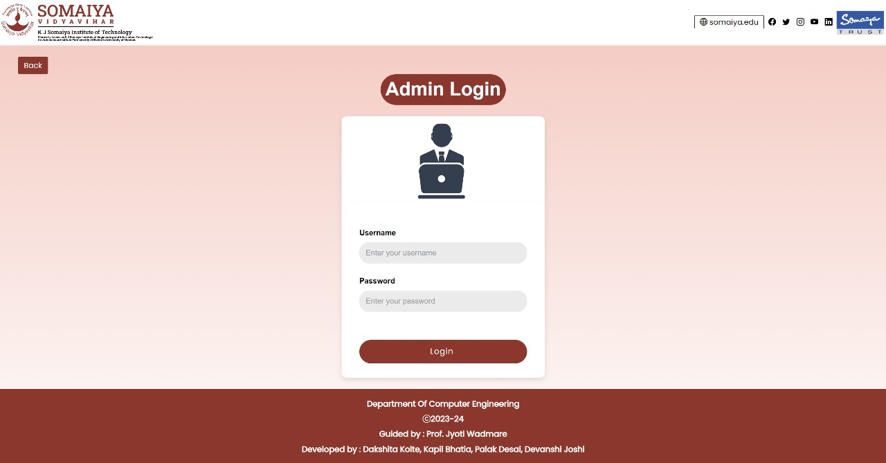

*Fig 6.12. Admin Login Page*

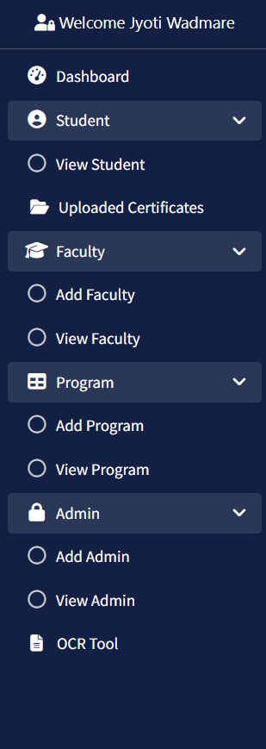

*Fig 6.13 Admin Sidebar*

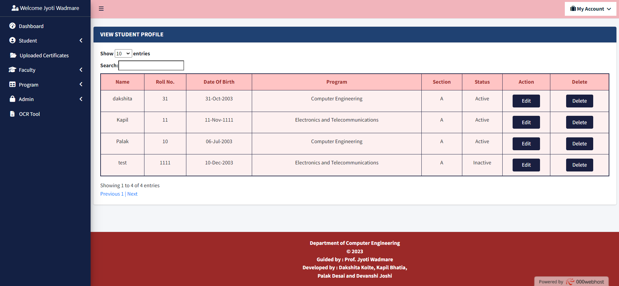

*Fig 6.14. View Student Profile Page*

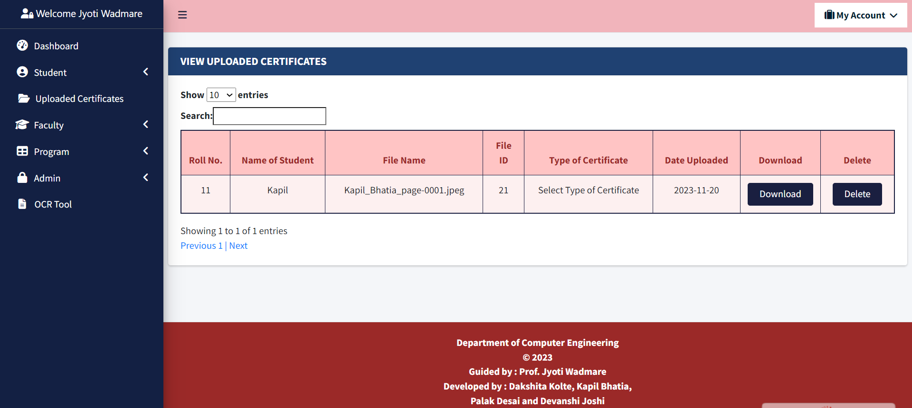

*Fig 6.15. View Uploaded Certificate Page*

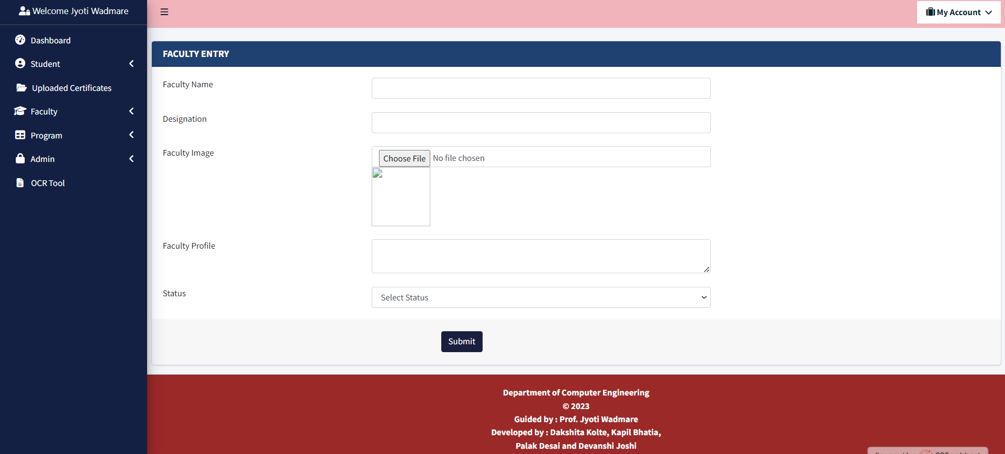

*Fig 6.16. Add Faculty Page*

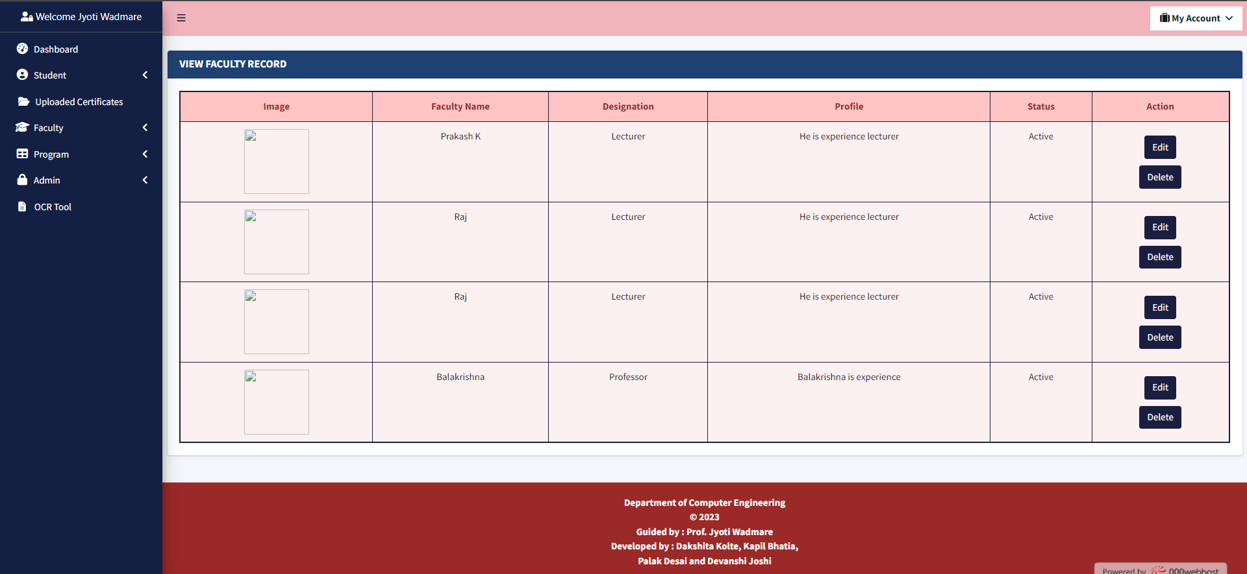

*Fig 6.17 View Faculty Record Page*

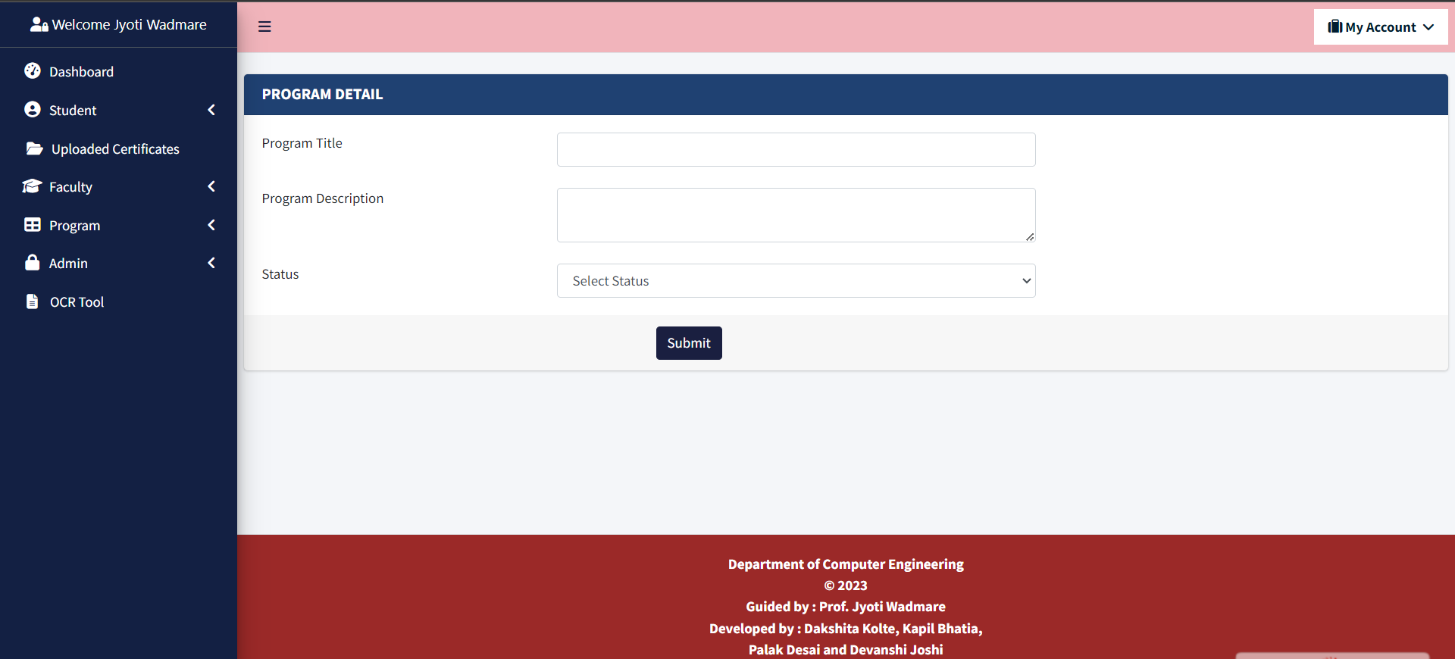

*Fig 6.18. Add Program Page*

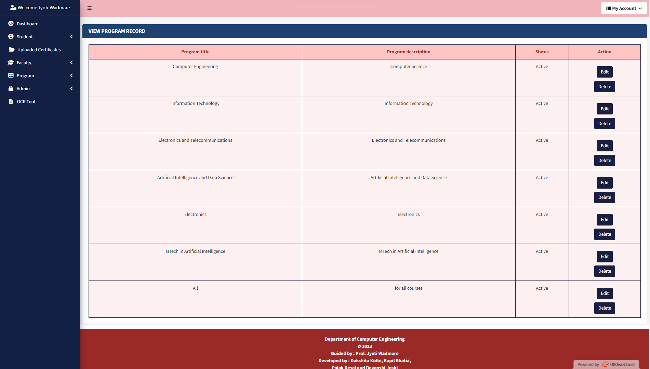

*Fig 6.19. View Program Details Page*

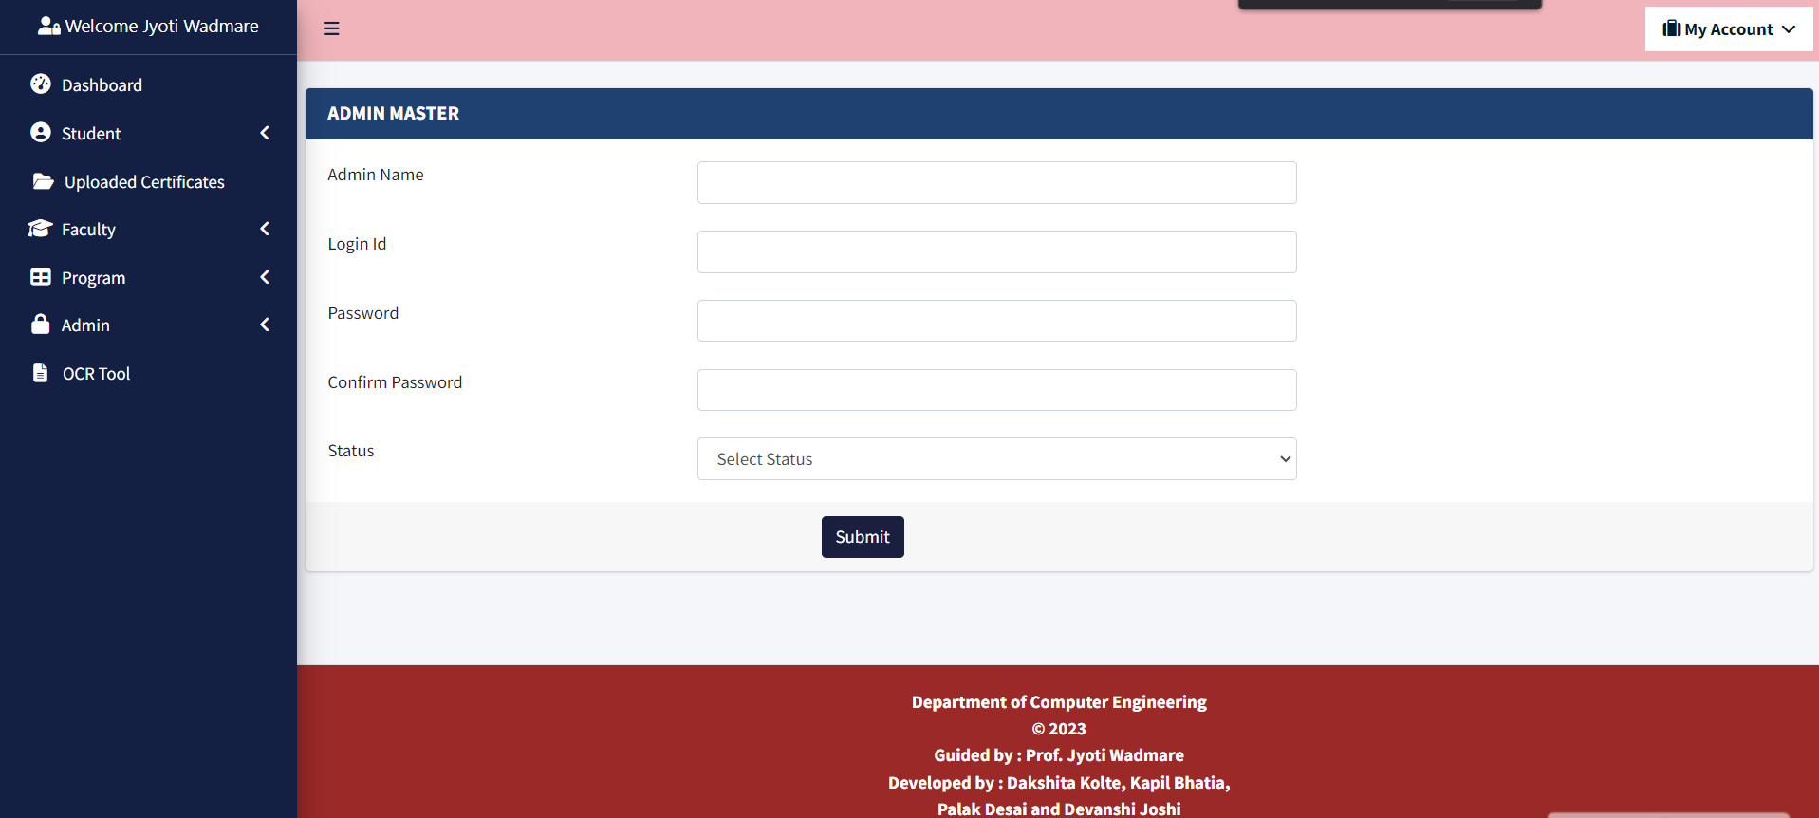

*Fig 6.20. Add Admin Page*

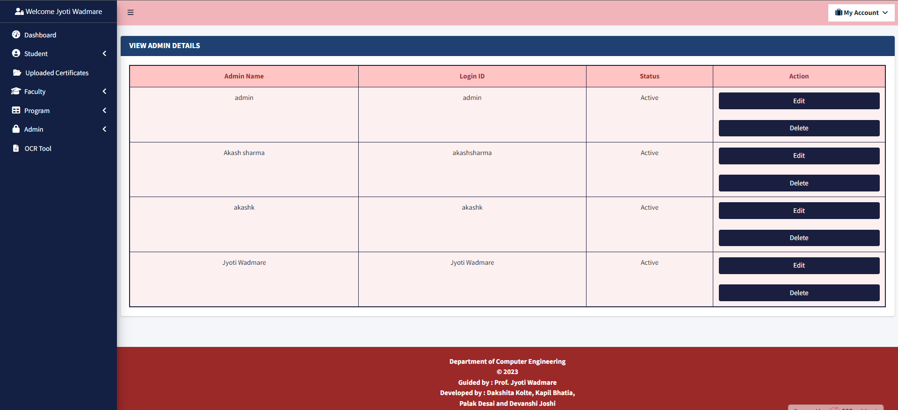

*Fig 6.21. View Admin Details Page*

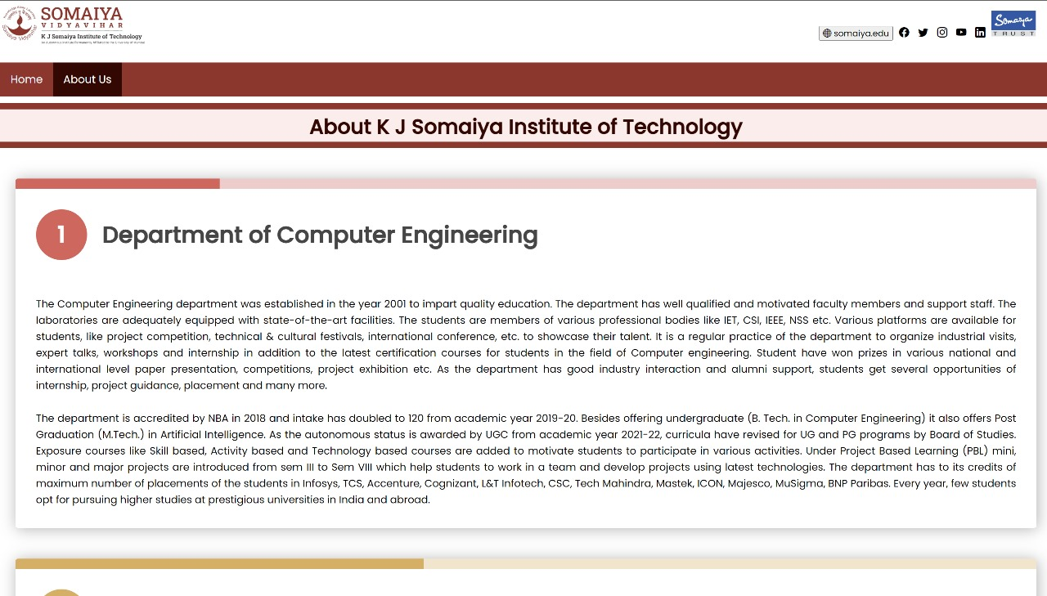

*Fig 6.22. About Us Page*

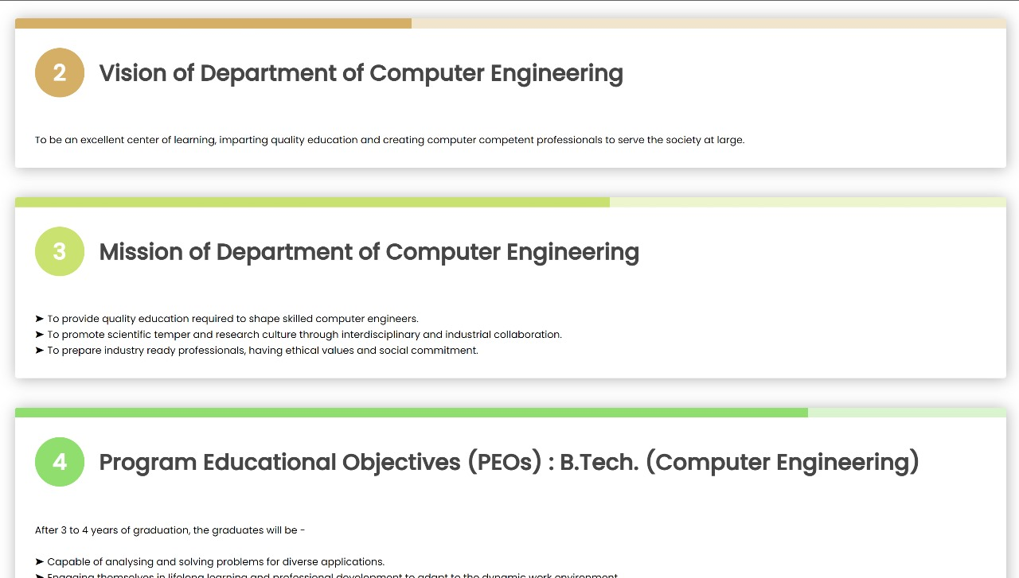

*Fig 6.23. About Us Page*

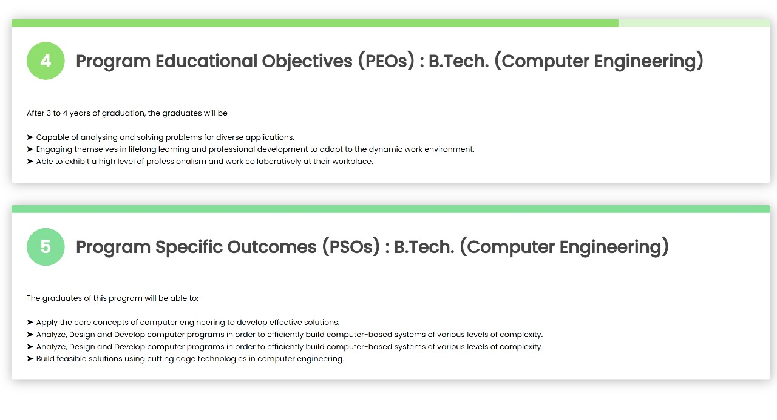

*Fig 6.24. About Us Page*

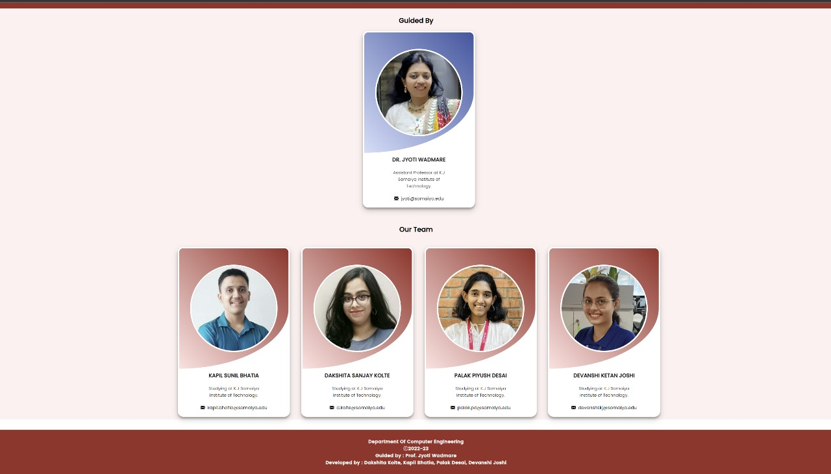

*Fig 6.25. About Us Page*

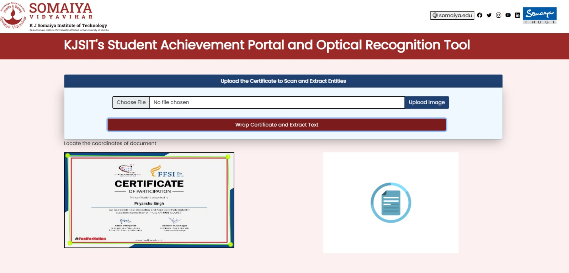

*Fig 6.26. Optical Character Resolution Tool Page*

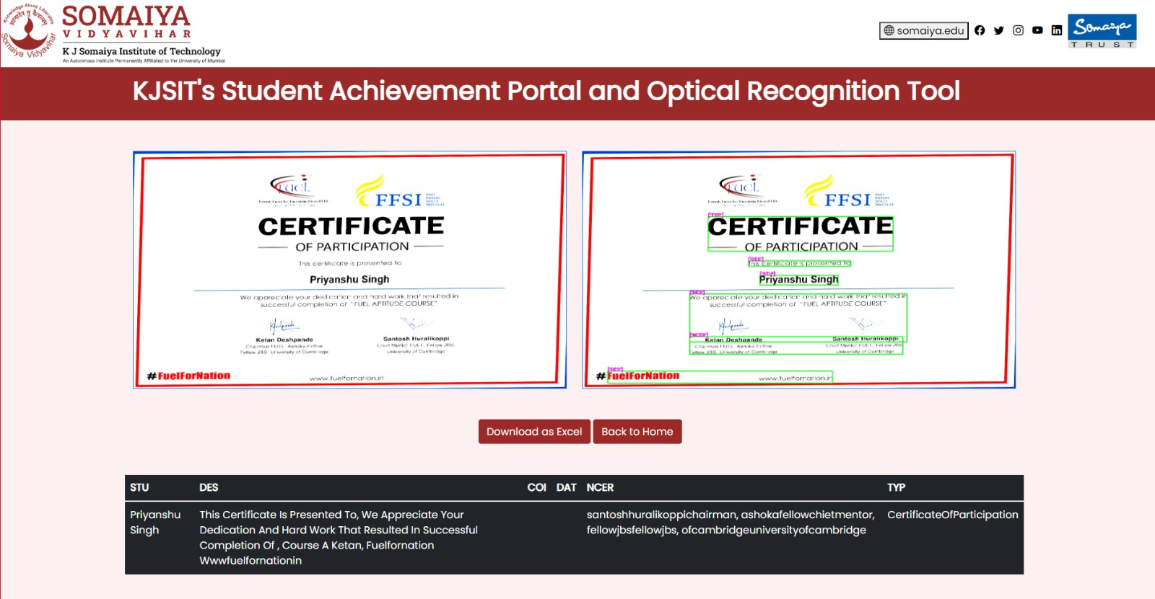

*Fig 6.27. Optical Character Resolution Tool Page*

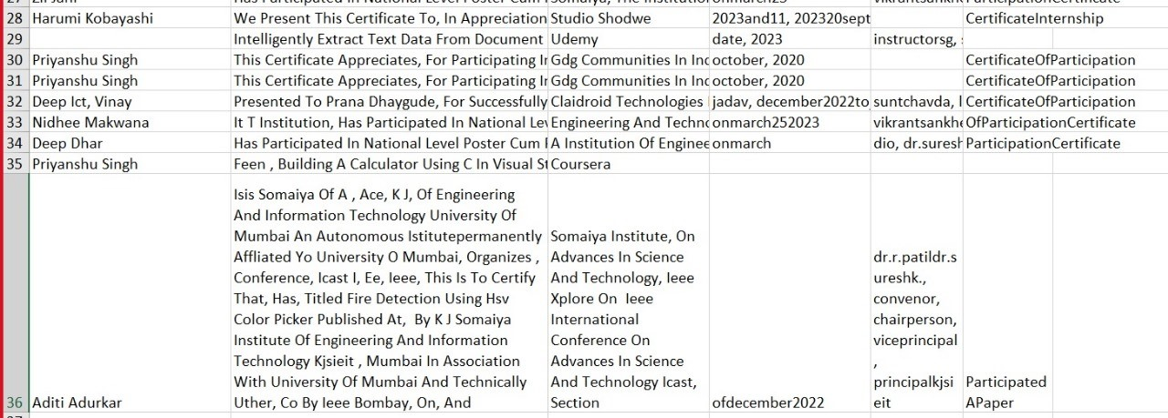

*Fig 6.28. Optical Character Resolution Tool Excel Downloaded*

**CHAPTER 7**

**RESULTS AND ANALYSIS**

KJSIT's Student Achievement Portal has been successfully developed, providing a user-friendly website that serves both students and admin. This comprehensive platform simplifies the collection and management of a wide range of certificates issued by students and is divided into two main sections: the Student and Admin sides.

In the Student section, students can easily register and log in to their accounts. They have the capability to upload their certificates, selecting the appropriate certificate type. Furthermore, they can manage their profiles and update their passwords as needed.

On the Admin side, administrators have access to the platform for various administrative tasks. They can monitor student registrations and activities, gaining insights into the certificates uploaded by students, including a comprehensive count for each certificate type. Admin also have the flexibility to view, edit, or delete user profiles, encompassing students, Programs, faculty, and fellow admin. Moreover, they can delve into the specific details of certificates uploaded by users.

The portal also incorporates a significant feature in the form of an Optical Character Recognition (OCR) Tool. This tool streamlines the process of uploading certificates, extracting crucial data, and storing this information efficiently in an Excel file. This Excel file acts as a centralized repository for all data collected from students, substantially reducing the manual administrative workload. The KJSIT's Student Achievement Portal aims to enhance the efficiency of collecting and managing student certificates, making the process user-friendly while automating data extraction and ensuring systematic storage for easy access and management.

**CHAPTER 8**

**CONCLUSION**

KJSIT's Student Achievement Portal, coupled with its integrated Optical Character Recognition (OCR) tool, represents a forward-thinking solution for the management of student achievements and records. This comprehensive system redefines the way certificates are collected and managed, introducing efficiency and user-friendliness for students and administrators alike. Some important points include:

1. Streamlining Certificate Management:

The portal's core objective is to streamline the collection and management of various certificates issued to students. In the traditional approach, this process could be tedious, involving the manual submission of certificates and data entry. The Student Achievement Portal revolutionizes this by offering an online platform where students can easily upload their certificates. This user-friendly approach simplifies the process for students, eliminating the need for physical document submission and multiple forms.

1. User-Friendly Interface:

The portal is designed with a user-friendly interface that makes it easy for students to navigate. They can log in or register, select the type of certificate they wish to upload, and manage their profiles and passwords. This simplicity encourages student engagement and ensures that certificates are easily accessible for upload.

1. Administrative Efficiency:

On the Admin side, the portal provides administrators with a suite of tools to effectively manage the certificates and student records. This includes the ability to track student registrations and activities, view, edit, or delete user profiles, and access detailed information about certificates uploaded by students. The system offers a comprehensive overview, helping administrators keep track of various aspects of student achievements.

1. The Power of OCR:

The true innovation lies in the integration of an Optical Character Recognition (OCR) tool. This tool automates the extraction of text from certificates. It reads the certificates, recognizes and captures critical information such as names, dates, and details of achievements, and converts this data into a digital format. This process eliminates the need for manual data entry, reducing the risk of errors and saving significant time and effort for administrators. The extracted data is neatly organized and stored in Excel files, providing a structured and easily accessible repository.

1. Cost-Effective Solution:

Beyond its practical benefits, the project also has an aim to provide a cost-effective OCR solution. While various paid OCR tools are available in the market, an initiative strives to offer this valuable service without the associated financial barriers.

In conclusion, KJSIT's Student Achievement Portal and OCR tool offer a comprehensive, user-friendly, and efficient approach to managing student certificates and records. The automation provided by the OCR tool significantly reduces the administrative workload, enhances data accuracy, and saves time. Moreover, the project's commitment to providing a cost-effective OCR solution demonstrates its dedication to accessibility and affordability in the realm of certificate management.

**REFERENCES**

[1]J. Memon, M. Sami, R. A. Khan and M. Uddin, "Handwritten Optical Character Recognition (OCR): A Comprehensive Systematic Literature Review (SLR)," in IEEE Access, vol. 8, pp. 142642-142668, 2020, doi: 10.1109/ACCESS.2020.3012542.

[2] Y. S. Chernyshova, A. V. Sheshkus and V. V. Arlazarov, "Two-Step CNN Framework for Text Line Recognition in Camera-Captured Images," in IEEE Access, vol. 8, pp. 32587-32600, 2020, doi: 10.1109/ACCESS.2020.2974051.

[3] A. A. Chandio, M. Asikuzzaman and M. R. Pickering, "Cursive Character Recognition in Natural Scene Images Using a Multilevel Convolutional Neural Network Fusion," in IEEE Access, vol. 8, pp. 109054-109070, 2020, doi: 10.1109/ACCESS.2020.3001605.

[4] J. Park, E. Lee, Y. Kim, I. Kang, H. I. Koo and N. I. Cho, "Multi-Lingual Optical Character Recognition System Using the Reinforcement Learning of Character Segmenter," in IEEE Access, vol. 8, pp. 174437-174448, 2020, doi: 10.1109/ACCESS.2020.3025769.

[5] M. Li, B. Fu, Z. Zhang and Y. Qiao, "Character-Aware Sampling and Rectification for Scene Text Recognition," in IEEE Transactions on Multimedia, vol. 25, pp. 649-661, 2023, doi: 10.1109/TMM.2021.3129651.